DEPARTMENT OF PATHOLOGY
DR.RAJENDRA PRASAD GOVT.MEDICAL COLLEGE KANGRA AT TANDA (H.P)
HFW-H(DRPGMC)/PATH/DIAMOnDS/2024-283 Dated 07-06-2024

In continuation to the notification HFW-H(DRPGMC)/PATH/2024-143-45,dated 21st March at DrRPGMC website,the date for the examination( written/interview) for the contractual posts under DIAMOnDS project has now been scheduled on 15th June 2024.
Only Eligible applicants are invited to the written test /interview with original documents.The candidates need to show their Photo ID’s like driving license / Aadhar card before entering the examination hall.
Venue:Paraclinical Block 3rd floor (Lecture theatre-PSM/Pharmacology)
Time of examination for the contractual posts:
For the post of Laboratory technician,Multitasking staff,Data Entry operator written test at 10 am followed by typing speed test for Data entry operator
For the post of Scientist -C and Research Assistant -written test at 12 noon ,followed by interview.
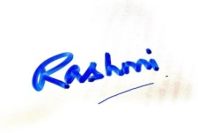

Dr Rashmi Kaul
Principal Investigator,DIAMOnDS Project
Deptt of Pathology,
DrRPGMC,Kangra at Tanda(HP)

