**STANDARD OPERATIVE PROCEDURES**

**First Edition 2015**



**DEPARTMENT OF SURGERY**

**DR RAJENDRA PRASAD GOVERNMENT MEDICAL COLLEGE KANGRA AT TANDA**

**PREFACE**

The Department of Surgery Dr. Rajindra Prasad Government Medical College, Tanda had hereby made an effort to bring forward first edition of Standard Operative Procedures guidelines for a range of surgical conditions. For preparing these standard operative procedure guidelines a committee of experts was constituted and they had wider consultations and extensive involvement of end users. These guidelines are intended as a ready reference for surgery residents and surgical paramedics.

Because of the dynamic nature of therapeutics and drug use patterns, these guidelines require review and updating on continuing basis. The dynamism of this document is very much dependent on the comments and feedback from the users who are therefore welcome to forward their comments and suggestions.

All the faculty members of Department of Surgery (Dr,.Ramesh Bharti, Dr.Sanjeev Sharma, Dr. Atul Mahajan, Dr. Raj Kumar, Dr. R K Abrol, Dr. Amar Verma, Dr. Rakesh Chauhan, Dr. Satish Kumar, Dr. Som Raj Mahajan, Dr. Sanjay Sood.) and Senior Residents (Dr. Ankit Shukla, Dr. Amit Ratan, Dr. Anupam Nanda, Dr. Arti Chaudhary, Dr Rajesh Chaudhary) have contributed a lot in preparing and giving final shape to this document.

It is hoped that these guidelines will prove a useful ready reference for the health care providers. This manual is neither restrictive nor prescriptive; it merely provides guidelines for treatment of various conditions and is not meant to be a substitute for clinical judgment and acumen.

Dr Ramesh Bharti Professor & Head Department of Surgery Dr RPGMC Tanda

**CONTENTS**

1. ACUTE ABDOMINAL PAIN
2. ACUTE APPENDICITIS
3. ACUTE PANCREATITIS
4. ACUTE CHOLECYSTITIS
5. CHOLELITHASIS
6. RENAL COLIC
7. TRAUMA(CHEST AND ABDOMEN)
8. UROGENITAL TRAUMA
9. UGI BLEED
10. BLEEDING PER RECTUM
11. GASTRIC OUTLET OBSTRUCTION
12. COLORECTAL DISEASES GENERAL
13. CONSTIPATION
14. PERIAMPULARY AND PANCREATIC CARCINOMA
15. HYDATID CYST
16. INGUINAL HERNIA
17. VENTRAL HERNIA
18. RENAL CELL CARCINOMA
19. BLADDER CANCER
20. PROSTATE CANCER
21. TESTICULAR TUMORS
22. BREAST MASS
23. BREAST PAIN
24. NIPPLE DISCHARGE
25. THYROID SWELLING
26. BURNS
27. SOFT TISSUE INFECTIONS
28. DIABETIC FOOT
29. CHRONIC VENOUS INSUFFICIENCY AND DVT
30. PERIPHERAL ARTERIAL DISEASES

**ABBREVIATIONS**

MRI –Magnet Resonance Imaging

NSAID-Non Steroidal Anti inflammatory drugs

CT-Computer Tomography

ESWL-Extra-corporeal Short Wave Lithotripsy

CEA-Carcino Embryonic antigen

CBC-Complete Blood Count

RFT-Renal function tests

LFT-Liver function tests

CXR-Chest X rays

ATT-Anti tubercular therapy

USG-Ultrasonography

NSS-Nephron Sparing Surgery

IL-Interleukin

IFN-Interferon

BTA-Blunt Trauma Abdomen

IVU-Intravenous Urography

PSA-Prostate Specific Antigen

TRUS-Trans Rectal Ultra Sonography

URS-Urodynamic Studies

PCNL-Per Cutaneous Nephro Lithotomy

NPO-Nil Per Orally

CVP-Central Venous Pressure

FNAC-Fine Needle Aspiration Cytology

CVI-Chronic Venous Insufficiency

LMWH-Low Molecular Weight Heparin

ABI-Ankle Brachial Index

CLI-Critical Limb Ischemia

AAA-Abdominal Aortic Aneurysm

FAST-Focussed Abdominal Sonography for Trauma

ABG-Arterial Blood Gases

TSH-Thyroid Stimulating Hormone

TBSA-Total Body Surface Area

BMI-Body Mass Index

ASD-Anti Septic Dressing

RPLND-Retro Peritoneal Lymph Node Dissection

PUD-Peptic Ulcer Disease

MI-Myocardial Infarction

GOO-Gastric Outlet Obstruction

HII-Heparin Induced Thrombocytopenia

PAD-Peripheral Arterial Disease

KUB-Kidney Ureter Bladder

SBP-Systolic Blood Pressure

RCC-Renal Cell Carcinoma

PR-Per Rectal

DRE-Digital Rectal Examination

I & D=Incision and Drainage

1. **ACUTE ABDOMINAL PAIN**

Common surgical conditions leading to acute abdominal pain are:

Acute peritonitis

Acute appendicitis,

Acute cholecystitis,

Acute pancreatitis,

Acute intestinal obstruction

Renal/ Ureteric colic.

In these situation proceed as under :

* Initial Assessment of Abdominal Pain
* Further Assessment of Abdominal Pain
* Management of Acute Abdominal Pain

Initial Assessment of Abdominal Pain

This will reflect the general clinical and severity of patient’s condition.

Look vitals(BP,Pulse, Respiratory rate)

Take quick history and examintation.

Hydration.In case patient is dehydrated put two large bore IV canulas and rush 1 lt of crystalloid .Cathetrize the patient to monitor urine output. In case if urine output is < 1ml/hr or BP <90 mm Hg Systolic despite fluid rush that Central venous access needs to be established to monitor CVP.

Further Assessment of Abdominal Pain

When patient is stable or unstable patient has been stabilised :

* Obtain a full history and examination.
* Consider the following investigations.
* CBC, urea, creatinine, serum electrolytes, random blood sugar.
* LFTs ( upper abdominal pain, biliary history )
* Amylase, lipase ( pancreatitis )
* Cardiac injury markers ( Upper abdominal/chest pain )
* ABG ( ischemic bowel disease )
* CXR, X-Ray abdomen standing and supine for perforation of gut, pneumonia, intestinal obstruction, renal colic
* USG for renal colic, acute appendicitis, acute cholecystitis, ruptured ectopic, salphingoophritis
* If needed CT scan to settle the issue

Management of Acute Abdominal Pain

* If definite diagnosis is established after the initial assessment, follow the appropriate pathway :Acute peritonitis, Acute appendicitis, Acute cholecystitis, Acute pancreatitis, Acute intestinal obstruction and renal colic.
* If none of these diagnosis is likely, then further investigation and treatment as directed by surgical team
* Consider referrals for other diagnoses i. e. Cardiology, Respiratory Services, OBG etc.

1. **ACUTE APPENDICITIS**

History & Examination

Investigations

Management

History & Examination

* H/O shifting pain, Murphy’s triad : pain, vomiting & fever.
* Check for RIF tenderness (McBurney’s point), rebound tenderness, guarding, signs of peritonitis.
* Check for fever, tachycardia.
* In females obstetric & gynaecological examination.
* Psoas sign-Extension of the hip joint causes pain.
* Obturator sign- flexion and internal rotation of hip may cause pain in hypogastrium.
* Rovsing sign-deep palpation of the left iliac fossa may produce pain in right iliac fossa.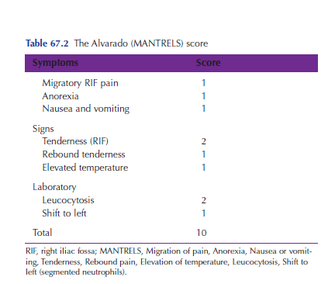
* Score of 7 or more is strongly predictive of acute appendicitis.

Investigations

* CBC and differential count
* Random blood sugar, Renal function tests
* Serum electrolytes ( Na, K &Cl )
* Pregnancy test in females
* Urinanalysis

Imaging

* More likely to be helpful if history/signs equivocal and in female patients.
* Abdominal X-Ray & CXR
* Abdominal & Pelvic ultrasound
* Consider CT if not clear

MANAGEMENT

Acute appendicitis : Appendectomy(Open or Laparoscopic)

* IV line and start IV fluids
* Prophylactic antibiotics.
* Analgesics

Appendicular lump-Manage as per Ochsner Sherren regimen

**3. ACUTE PANCREATITIS**

Incidence of acute pancreatitis had increased in the past 20 years.

Most patients –mild to self limiting disease.

10-20% rapidly progressive inflammatory disease with significant morbidity and mortality.

Most common cause of death is MODS.

**RISK FACTORS**

Gall stones

Alcohol

Anatomical obstruction

ERCP

Drugs-sulfonamides, metronidazole, erythromycin, tetracycle, didanosine, thiazides, frusemide, HMG CoA Reductors, 6 mercaptopurine,5-amino salicylic acid, sulphasalazine, valproic acid, acetaminophen.

Metabolic factors-hypertriglycedemia, hypercalcemia.

Miscellaneous conditions-abdominal trauma, prolonged intraoperative hypotension, excessive pancreatic manipulation during surgery.

**Clinical features**

* Epigastric/periumblical pain radiating to back.
* Vomiting.
* Fever
* Dehydration
* Tachycardia.
* Respiratory distress.
* Peritonism.
* Decreased BP, urine output.
* Peri umbilical ecchymosis- Cullen’s sign
* Flank ecchymosis-Gray Turner sign.

**Work up**

* Hb
* TLC.
* DLC.
* Serum amylase and lipase.
* LFT.
* RBS.
* USG abdomen.
* CT abdomen- best modality.

**Management**

* NPO.
* Ryle’s tube aspiration.
* IV fluids.
* Prophylactic antibiotics.
* Proton pump inhibitors.
* PR, BP,RR, SpO2, Urine output, CVP to be monitored.
* On resolution of pancreatitis, if biliary consider for elective cholecystectomy after 6 weeks.
* If alcohol induced, patient to strongly advised regarding alcohol abstinence.
* Dietary advice.
* Pancreatic enzymes to be supplemented.
* Patient to be kept on follow up for the development of DM and other complications like pancreatic pseudocysts , necrosis, fistula or ascites.
* If patient does not resolve in intensive care then patient is advised to proceed to GI surgery unit where necrosectomy may be required.

**4. ACUTE CHOLECYSTITIS**

**ETIOLOGY**-

Calculus cholecystitis -Obstruction of the cystic duct from stone impactation is the most common cause of cholecystitis

Acalculus cholecystitis- Older age

Critical illness

Burns

Trauma

Prolonged use of TPN

DM

Immunosupression

**Clinical features**

* Pain in right hypochondrium, epigastrium.
* Vomiting.
* Fever
* Tenderness in right hypochondrium.
* Positive Murphy’s sign

**Work up**

* Hb.
* TLC.
* DLC.
* LFT.
* Serum amylase, lipase.
* USG abdomen- sensitive, inexpensive, reliable tool for diagnosis.

**Management**

* NPO.
* Ryle’s tube aspiration.
* Antibiotics.
* Analgesics.
* Spasmolytics.
* Proton pump inhibitors.
* On resolution- plan for cholecystectomy after 6weeks.

5. **CHOLELITHASIS**

Majority of gallstones are asymptomatic.

Detected incidentally at the time of abdominal ultrasound for other reasons.

Only 20-30% of patients with asymptomatic stones will develop symptoms within 20 years.

1% of patients with asymptomatic stones develop complications.

Prophylactic cholecystectomy is not warranted in asymptomatic patients.

**Symptoms**-Mostly asymptomatic

Recurrent attacks of cholecystits ( pain in right hypochondrium, vomiting, fever, Murphy’s sign positive).

**Management-**

Specific-USG Abdomen

Work up for surgery-Hb, TLC, DLC, Platelets, BT, CT, LFT

CXR-P/A

ECG

**Symptomatic**

* Cholecystectomy – Laproscopic/open.

**Asymptomatic**

Indication for cholecystectomy:

* Children.
* Young patients.
* Hemolytic anemia.
* Stone size >3cms.
* Porcelain gallbladder.
* Diabetics.
* Associated gall bladder polyp >1cms.

Elderly patients with co-morbidity to be managed conservatively.

**6. RENAL COLIC**

**Clinical features**

* Typically occurs at night / early morning affecting patient at rest.
* Abrupt onset, begins in flank, radiates around abdomen. .
* As stone progresses down ureter may get pain in groin and testes / labia.
* Nausea, vomiting, intestinal ileus common.
* Typically severe discomfort and inability to find comfortable position.
* Pale, sweating, tachycardic
* Mild tenderness on affected side
* Genital and rectal examination essential
* Fever uncommon, but may suggest coexisting infection
* May be associtated with UTI and hematuria.

**Differential Diagnosis of renal colic**

* Gastro-enteritis
* Acute appendicitis
* Diverticulitis
* Salpingitis
* Cholecystitis
* Pyelonephritis

**Investigations**

* Urine analysis
* Urine for culture and sensitivity
* Ultrasonography
* X ray – KUB
* Intravenous urography

**Management of Stones**

Conservative Management

* Is the initial management of most stones
* Analgesia, antispasmodics,antiemetics +/- IV fluids (no benefit from forced diuresis)

Extracorporeal Shock Wave Lithotripsy

* Now the treatment of choice for the majority of renal and ureteric calculi
* Performed on outpatient basis
* Minimal complication rate
* High success rates, though repeat procedures usually necessary

Percutaneous Nephrolithotomy

* For renal, or upper ureteric stones too large for ESWL
* Initial management of choice for Staghorn stones where renal function worth preserving
* Track into kidney made by radiologist/Urologist.
* Stones fragmented under direct vision

Ureteroscopy

* Made much safer and easier by development of miniature ureteroscopes
* Ureteroscopy performed under GA
* Trauma to ureter from ureteroscope is main complication
* Stone may be
  + removed by Dormia Basket
  + Fragmented by ultrasound, laser, Lithoclast

Open Procedures

* Now restricted to:
  + Stones that cannot be removed by other means.
  + In a morbidly obese patient (other procedures technically impossible)
  + In a patient whose poor health precludes other procedures
  + For large, complex, Staghorn calculi.

Management of stones in Pregnancy

* U/S may show hydronephrosis - compatible with normal pregnancy.
* Other choices include percutaneous nephrostomy tube drainage, and open lithotomy
* ESWL is considered contraindicated (?effects on foetus, use of x rays)
* Open surgery is contraindicated in last half of pregnancy for lower ureteric stones.

Management of bladder stones

* Endemic bladder stones of South East Asia do not recur when removed
* Bladder stones do not occur in western population in the absence of significant obstruction, which must also be corrected
* Choice of procedures
  + ESWL
  + Litholapaxy
  + Open Lithotomy.

**7. TRAUMA**

Trauma is managed according to the Advanced Trauma Life Support protocols (ATLS).

**ASSESS AIRWAY**

* Elicit verbal response

**Unstable** **Stable**

**TRAUMA**

On arrival in casualty

**ASSESS DISABILITY**

* GCS
* Limbs

2 Large bore IV cannula 1-2 liters warm crystalloid rush also look for Tension pneumothorax and asses for blood loss

* Chest & abdomen- EFAST
* Pelvis X- ray
* External loss
* Neck

**Supplement O2 / Assisted ventilation**

Consider Tube drainage (Thoracostomy)

**Establish stable airway**

* Endotracheal intubation
* Surgical airway

**EXPOSE AND EXAMINE THOROUGHLY**

**ASSESS BREATHING**

* Physical examination
* SpO2

**Inadequate**

**WELL**

**ASSESS CIRCULATION**

* Physical examination
* Vitals sign

**SHOCK**

**CHEST TRAUMA**

**UNSTABLE**

* Send blood examination
* Arrange blood.

**STABLE**

* Physical examination
* Chest x ray

OUTPUT <1500ml

FAST

Immediate Tube thoracostomy

B/L if needed

Monitor

ECHO + CT Chest

Bronchoscopy

Heamo/pneumothorax

Trans-mediastinal injury

Tube thoracostomy

**YES NO** CHECK SpO2/VITALS

**YES NO**

OUTPUT >1500 ml

OT/THORACOTOMY

**NO**

RESPONDS TO RESUCITATION

**YES**

MONITOR

**PENETRATING ABDOMINAL TRAUMA**

Explore If Needed

CECT Abdomen

No Peritonitis

Discharge

Peritonitis +ve

Explore laprotomy

* Hb<3gm%
* Leucocytosis

Admit for observation

Serial examination

* Peritonitis
* Hb

NEGATIVE

Positive/ Equivocal

**EXPLORE**

**NO**

Local wound exploration

**YES**

Shock/Peritonitis/Evisceration

**ABDOMINAL TRAUMA**

No

Serial monitoring

Yes

* Large Amount
* Abnormal vitals
* Patient deteriorating

No

Observe

No

Conservative Management

Yes

Consider Exploratory Lap

NO

Free Fluid

YES

Grade iv/v spleenic or pancreatic injury

Exploratory Laprotomy

Solid organ injury

Hollow viscous perforation

CECT Abdomen

Exploratory laprotomy

No Peritonitis

Peritonitis

Stable

Operate

Unstable despite resuscitation

**8. UROGENITAL TRAUMA**

3% to 10% of trauma patients have genito urinary injuries

10-15% of trauma patients with abdominal injuries have genito urinary involvement.

**Renal Injury**

* Renal injuries constitute 45% of all genito urinary injuries.
* Most renal injuries (80%) are minor and do not require surgical intervention.
* Renal trauma can happen in either blunt or penetrating trauma.
* Renal injuries are most commonly from motor vehicle accidents (MVAs).

**Clinical findings**

* The most important indicator of renal trauma is gross or microscopic hematuria.
* The absence of hematuria, although rare, does not exclude renal injury because it is absent in 5% of patients.
* Flank ecchymosis or mass indicates a retroperitoneal process but is not specific to renal injuries and rarely occurs acutely.

**Investigations**

* Hemoglobin.
* Urine analysis.
* IVP - double dose
* CT Scan - best method of staging - radiographic study of choice
* Ultrasound
* Angiography - used for suspected renovascular injury

**Treatment**



**Ureteral Injury**

* Ureteral injuries after external violence are rare, occurring in less than 4% of cases of penetrating trauma and less than 1% cases of blunt trauma.
* This is more common during hysterectomy.

**Clinical features**

* Loin pain and fever – in case of pyonephrosis.
* Majority are asymptomatic.
* Urinary fistula after abdominal and vaginal hysterectomy.
* Bilateral injury – anuria.

**Investigations**

* Excretory urogram – extravasations of the contrast.

**Treatment**

* No loss in length- spatulation and end to end anastamosis.
* Little loss of length- mobilize kidney, psoas hitch of bladder, Boari operation.
* Marked loss of length- Transureteroureterostomy, interposition of isolated bowel loops or mobilized appendix, Nephrectomy.

**BLADDER INJURY**

Bladder injuries classified into contusions, extraperitoneal and intraperitoneal ruptures.

Mostly occur in blunt trauma. Eighty-five percent of these injuries occur with pelvic fractures.

15% occur with penetrating trauma and blunt mechanism without a pelvic fracture (ie, full bladder blowout).

**Clinical features**

* Gross hemeturia is the most important clinical feature.

**Investigation**

* Plain x ray abdomen- ground glass appearance.
* Intravenous urogram- leak from bladder can be seen.
* Retrograde cystography.

**Treatment**

* Intraperitoneal injury – laprotomy, repair of bladder injury and peritoneal lavage.
* Extraperitoneal injury – catheter drainage of bladder for 10 days.

**URETHRAL INJURY**

* Almost exclusively in male.
* Most common in straddle injure.
* Significantmorbidity
  + Stricture
  + Incontinence
  + Impotence
* Foley catheter implication.

**Clinical features**

* Posterior Urethra-Gross hematuriain 98%, Inability to void, Blood aturethralmeatus, Pelvic / suprapubictenderness, Penile / scrotal / perinealhematoma, Boggy / high-riding prostate/ ill-defined mass on rectal examination.
* Anterior Urethra-More commonthanposterior, Direct trauma, Usually NO pelvicinjury , Blood at meatus, Unable to micturate, Penile/Scrotal/Perineal, Contusion, Hematoma, Fluid collection

**Investigations**

* Urethrogram is the best diagnostic tool.
* Contrast extravasaton+ contrast in bladder- extravasation.
* Only ct contrast enhancement- complete tear.

**Treatment**

* Partial tear-careful passage of 12-14 Fr. Foley catheter, in case of any resistance refer the patient to urologist.
* Complete tear: SPC and Urology consultation.
* If Foley’s catheter in situ and tear is suspected: keep Foley’s in situ and refer the patient to urologist.

9. **UPPER GI HEMORRHAGE**

Upper GI bleeding refers to bleeding that arises from the GI tract proximal to the ligament of Treitz; it accounts for almost 80% of significant GI hemorrhage

The causes of upper GI bleeding are 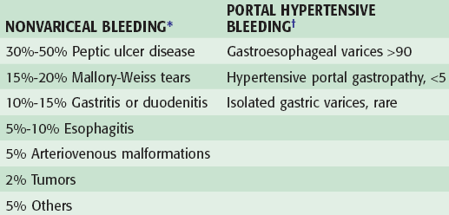

Algorithm for the diagnosis and management of variceal

upper GI bleeding.

A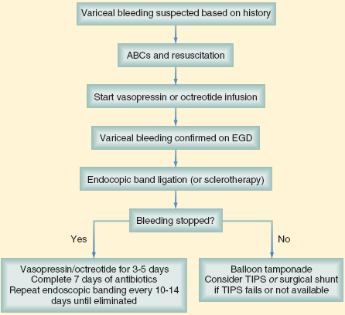

Algorithm for management of non variceal bleed

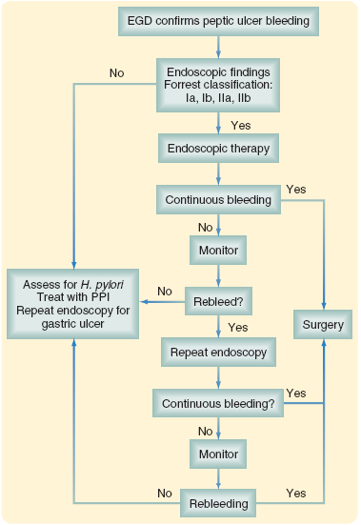

**10. BLEEDING PER RECTUM**

Bleeding PR/ acute lower GI bleed

Yes No

Assess for anorectal bleeding Digital rectal exam and anoscopy

Angiography and

treatment

Hemorrhoids

Anal fissure

Fistula in Ano

Ruptured perianal abscess

Growth

Segment resection

Repeat colonoscopy if re-bleeds

Tagged RBC scan

Stable

Unstable

Colon or small bowel identified as source

Subtotal colectomy with ileorectal anastomosis or small bowel resection

Operating room

Source uncertain

Small bowel series EnteroclysisEnteroscopy Capsule endoscopy

Localized bleeding,Serial clamping or intraoperative enteroscopy followed by resection

Biopsy and Initiate appropriate therapy as per cause

No lesion visualized and/or continued bleeding

Lesion visualized

Colonoscopy / CECT abdomen & pelvis

Major bleeding (persistent)

Minor bleeding (intermittent)

Scan Upper GI bleeding

algorithm

Rule out upper GI bleeding NGT aspirate or EGD positive

**11. GASTRIC OUTLET OBSTRUCTION**

CAUSES

|  |  |
| --- | --- |
| **BENIGN** | **MALIGNANT** |
| PUD | Pancreatic cancer |
| Gastric polyps | Ampullary cancer |
| Ingestion of caustics | Duodenal cancer |
| Pyloric Stenosis | Cholangiocarcinomas |
| Congenital Duodenal Webs | Gastric cancer |
| Pancreatic pseudocysts |  |
| Bezoars |  |
| Gallstone obstruction (Bouveret syndrome) |  |

**Presentation**

* Nausea and vomiting are the cardinal symptoms of gastric outlet obstruction.
* Vomiting - nonbilious, contains undigested food particles.
* early satiety, bloating or epigastric fullness, indigestion, anorexia, nausea, vomiting, epigastric pain, and weight loss.
* Weight -malignant disease.
* Abdominal pain- PUD, pancreatic cancer.

**Physical examination**

* chronic dehydration and malnutrition.
* A dilated stomach may be appreciated as a tympanitic mass in the epigastric area and/or left upper quadrant.

**Laboratory Studies**

• CBC- hemoglobin to rule out anemia.

• electrolytes

• Liver function tests-To rule out malignant etiology .

• H Pylori-when the diagnosis of PUD is suspected.

**Imaging Studies**

• Plain radiographs, including the obstruction series (ie, supine abdomen, upright abdomen, chest posteroanterior), can demonstrate the presence of gastric dilatation and may be helpful in distinguishing the differential diagnosis.

• Contrast upper GI studies (Gastrografin or barium), and CT scans with oral contrast are helpful- The point of obstruction is visualized at the pyloric-duodenal junction (string sign).

**Diagnostic Procedures**

• Upper GI endoscopy can help visualize the gastric outlet and may provide a tissue diagnosis when the obstruction is intraluminal.

• The sodium chloride load test is a traditional clinical non-imaging study that may be helpful- The traditional sodium chloride load test is performed by infusing 750 cc of sodium chloride solution into the stomach via a nasogastric tube (NGT). A diagnosis of gastric outlet obstruction (GOO) is made if more than 400 cc remain in the stomach after 30 minutes.

• Barium upper GI studies -To delineate the gastric silhouette and demonstrate the site of obstruction. An enlarged stomach with a narrowing of the pyloric channel or first portion of the duodenum helps to differentiate GOO from gastroparesis.

• The specific cause may be identified as an ulcer mass or intrinsic tumor.

• In the presence of PUD, perform endoscopic biopsy to rule out the presence of malignancy.

• In the case of peripancreatic malignancy, CT scan–guided biopsy may be helpful in establishing a preoperative diagnosis.

• Needle-guided biopsy also may be helpful in establishing the presence of metastatic disease. This knowledge may impact the magnitude of the procedure planned to alleviate the GOO.

**Medical Therapy**

* admit patients for hydration and correction of electrolyte abnormalities.
* sodium chloride- initial IV fluid of choice.
* Potassium replacement
* Place a NGT to decompress the stomach
* Treat *H pylori* infection, when identified

**Surgical Therapy**

***Management of benign disease***

* vagotomy and antrectomy
* vagotomy and pyloroplasty
* Truncal vagotomy and gastrojejunostomy
* Pyloroplasty

***Management of malignant disease***

* Gastrojejunostomy - surgical treatment of choice
* Self-expandable metallic stents

**12. COLORECTAL DISEASES GENERAL**

**HISTORY-**

1. **Bleeding Per Rectum**
2. **Pain abdomen**
3. **Constipation**
4. **Chronic diarrhea**
5. **Weight loss, SOB, easy fatigabulity, loss of apetite**
6. **Lump abdomen**
7. **Anorectal pain**
8. **Jaundice**

**CLINICAL EXAMINATION-**

1. **Pallor**
2. **Cachexia**
3. **Distention**
4. **Tenderness**
5. **Lump abdomen**
6. **Visible peristaltic loop**
7. **Hepato-megaly**
8. **Bleeding PR**
9. **Rectal examination- growth, hemorrhoids, prolapse, fissure, fistula in ano, ballooning, ruptured abscess**

**INVESTIGATIONS-**

**Diagnostic –**

**a) X-ray abdomen**

**b) USG abdomen**

**c) CECT abdomen & pelvis**

**d) Proctoscopy/Sigmoidoscopy/Colonoscopy**

**e) Tumor markers- CEA**

**f) Biopsy/Cytology**

**Routiene-**

**a)CBC**

**b)RFTs**

**c)Electrolytes**

**d) LFTs**

**e)CXR**

**TREATMENT-**

1. **Abdominal tuberculosis- ATT/Strictroplasty/Resection anastamosis/ limit resection**
2. **Inflammatory bowel disease- medical treatment ( steroids/**

**Sulfasalazine etc)/ resection of segment(pancolectomy)**

1. **Malignancy- treatment as per stage followed by chemo-radiotherapy**
2. **Hemorrhoids- grade 1,2,3- conservative/ grade 4 hemarrhoidectomy**
3. **Fistula in ano- fistulectomy**
4. **Anal fissure- conservative/internal sphincterotomy**
5. **Abscess- de-roofing**

**13. CONSTIPATION**

Follow up

Manage as per cause

Definitive management as per stage

Explorative laparotomy

Explorative laparotomy & divisional colostomy & biopsy

No

CECT Abdomen & pelvis, routine investigations

Follow up & surgical management

No

Yes

Malignant

Punch biopsy & cytology

Treatment as per cause

Biopsy & Cytology

Colonoscopy

Yes

Yes

No

Growth

Growth

PR &Proctoscopy

PR &Proctoscopy

Complete obstruction

Incomplete obstruction

History & examination

Management as per Stage & follow up

**14. PERIAMPULLARY AND PANCREATIC CARCINOMA**

Patients presents with h/o painless, progressive jaundice.

**On examination**

* Jaundice is present.
* Gall bladder is palpable.

**Work up**

* Hb.
* TLC
* DLC.
* LFT
* RFT
* Chest X-ray PA.
* US abdomen.
* CECT abdomen-look foe size of the tumor and invasion of the portal vein, superior mesenteric vein & artery, surrounding structures, ascitis, lymphadenopathy and liver metastasis.

**Management**

* If total bilirubin is >20 mg% then consider ERCP stenting and biopsy**.**
* If total bilirubin is <20 mg% patient may be taken up for pancreaticoduodenectomy after proper hydration correction of coagulation profile and ensuring respectability and operability.

**15. HYDATID CYST**

* Zoonotic disease caused by Echinococcus.
* Man accidental intermediate host becomes infected by ingestion of eggs of tapeworm.

**CLINICAL SYMPTOMS**

* Right upper quadrant pain/discomfort.
* Dyspepsia
* Vomiting
* Non specific fatigue
* Asymptomatic
* Weight loss
* History of jaundice
* Fever
* Allergy
* Palpable right upper quadrant mass
* Pleural effusion
* Skin rash
* Dyspnoea

**Work up**

* USG abdomen.
* CXR-PA.
* CECT abdomen.
* Hydatid serology.
* ERCP in selective cases.
* Routine work up.

**Management**

* Medical –Albendazole.It is indicated in – inoperable patients with primary liver hydatosis

Patients with multiple cysts in two or more organs.

Multiple small liver cysts.

Cysts deep in liver parenchyma.

Prevention and management of recurrent hydatosis.

* PAIR- Percutaneous drainage of hydatid cysts indicated in cases of inoperable patients

Patients who refuse surgery.

Relaps after surgery

Failure of chemotherapy

Multiple cysts with < 5 cm diameter located in different liver segments.

Pregnant woman as chemotherapy is contraindicated.

Children less than 3 years of age.

* Surgery –Cystectomy with omentoplasty.
* In case of cystobiliary communication manage accordingly/
* Rule out lung hydatid cyst which needs to be dealt first.
* If calcification is present in X ray around the cyst it may again managed conservatively.

**16. INGUINAL HERNIA (DIRECT AND INDIRECT)**

**HISTORY-**

Reducible swelling in inguinal/inguinoscrotal region

**EXAMINATION**

Site of swelling

Overlying skin

Extend of swelling

Visible peristalsis

Whether swelling gets reduced of its own on lying down

Cough impulse

**PALPATION**

Temperature

Tenderness

Extent

Whether able to reach above the swelling or not

Reducibility

Ring occlusion test

Hernia appears medial to occluded finger-direct hernia

Indirect hernia will not find access

Invagination test-

If cough impulse felt on pulp of finger-direct hernia

If cough impulse felt on tip of finger-Indirect hernia

Zieman’s technique-

If cough impulse felt on index finger-indirect hernia

If cough impulse felt on middle finger-direct hernia

If cough impulse felt on ring finger-femoral hernia

If pressure is exerted over femoral canal hernia will not come-femoral hernia

**PERCUSSION**

Swelling is resonant

**AUSCULTATION**

Bowel sounds may be heard over the hernia

**INVESTIGATION-**

Mostly directed toward surgery-

CBC

Coagulogram

ECG

SERFT

LFTs

CXR

VIRAL MARKERS (HBsAg, HIV ,HCV)

**TRAETMENT-**

**LICHTENSTEIN TENSION FREE MESH HERNIOPLASTY/PROLENE HERNIA SYSTEM**

**CONGENITAL INGUINAL HERNIA –HERNIOTOMY**

**FEMORAL HERNIA-FEMORAL HERNIA REPAIR, SAC APPROACHED THROUGH EITHER SUPRAINGUINALLY (Mcevedys),INFRAINGUINALLY (Lockwood),or inguinal canal (Lotheisson).**

**17. VENTRAL HERNIA**

**INVOLVES-**

**EPIGASTRIC HERNIA**

**UMBLICAL HERNIA**

**INCISIONAL HERNIA**

**HYPOGASTRIC HERNIA**

**EPIGASTRIC HERNIA-** occur from the xyphoid process to the umbilicus

**UMBLICAL HERNIA-** occur from the xyphoid process to the umbilicus

**3 ) INCISIONAL HERNIA-** Acquired hernias typically occur after

surgical incisions

**4)HYPOGASTRIC HERNIA-** rare spontaneous hernias that occur

below the umbilicus in the midline.

**HISTORY-**

Reducible swelling in epigastric/umbilical/hypogastric/previous surgical incision site.

**EXAMINATION-**

**REDUCIBILITY PRESENT**

**COUGH IMPULSE PRESENT**

**PERCUSSION**

Swelling is resonant

**AUSCULTATION**

Bowel sounds may be heard over the hernia

**INVESTIGATION-**

**DIAGNOSTIC-**

**X-ray abdomen**

**USG ABDOMEN if signs of obstruction**

**ROUTINE-**

**CBC**

**RFTs**

**ELECTROLYTES**

**LFTs**

**CXR**

**VIRAL MARKERS (HBs,HIV,HCV)**

**TREATMENT-**

**UMBILICAL AND EPIGASTRIC HERNIA -**

**Mayo’s repair-if defect is of size 3cm**

**Onlay mesh hernioplasty-if defect is >3cm**

**INCISIONAL HERNIA-**

**Primary repair-if defect of small size (<2cm-3cm)**

**Inlay mesh hernioplasty-if defect is of size >3cm/laproscopic**

**Intraperitoneal mesh hernioplasty**

**HYPOGASTRIC HERNIA-PRIMARY REPAIR/MESH HERNIOPLASTY**

**18. RENAL CELL CARCINOMA**

* RCC accounts for 2% to 3% of all adult malignancy
* Renal tumor is the most lethal of all urologic cancers.
* RCC occurs most commonly in 5th~6th decade
* Male-female ratio 1.6:1.

**Etiology**

* Majority of RCC occurs sporadically.
* Tobacco smoking contributes to 24-30% of RCC cases.
* Occupational exposure to cadmium, asbestos, petroleum.
* Obesity.
* Chronic phenacetin or aspirin use.
* Acquired polycystic kidney disease due to dialysis results in 30% increase risk .
* 2-4% of RCC associated with inherited disorder.

**Clinical Findings**

* Renal tumors are increasingly detected incidentally by CT or ultrasound.
* Gross hematuria, flank pain, palpable mass (only in 10~15% advanced cases).
* Symptoms secondary to metastatic disease: dysnea& cough, seizure & headache, bone pain.

**Investigations**

* CBC.
* ESR.
* Urine analysis.
* Ultrasonography .
* Intravenous Urography (IVU).
* CT scan.
* Renal Angiography.
* MRI: to evaluate collecting system and IVC involvement.

**Treatment**

**A. Localized disease:**

* Radical Nephrectomy (en bloc removal of the kidney and Gerota’s fascia including ipsilateral adrenal, proximal ureter, regional lymphadenectomy .
* Partial Nephrectomy(nephron-sparing surgery, NSS )(polar tumor, tumor size<4cm, bilateral RCC, solitary kidney).
* Percutaneous/Laparoscopic Radiofrequency Ablation or Cryoablation.

**B. Disseminated disease:**

* Nephrectomy--- reducing tumor burden.
* Radiation--- radioresistant tumor, metastases 2/3 effective.
* Chemotherapy--- <10% effective.
* Immunotherapy--- IL-2/interferon-alpha, 30% response rate.
* Molecular therapy---*eg.*Sorafenib.

**19. BLADDER CANCER**

* The second most common cancer of the genitourinary system (most common in China).
* Male-female ratio= 2.7:1.
* Peak incidence b/w 50-70 years.

**Etiology**

* Industrial toxins.
* Cigarette smoking.
* Genetic events.
* Cyclophosphamide, alkylating agents,
* Radiotherapy of pelvis.

**Clinical Findings**

* Painless Hematuria 85~90%.
* Irritative voiding symptoms.
* The majority of patients have no pertinent physical signs.

**Investigations**

* Urine analysis
* Urinary cytology——depend on grade and volume of the tumor.
* Ultrasonography.
* IVU.
* CT/MRI—assessment of the depth of infiltration and pelvic LN enlargement.
* Cystoscopy + Biopsy
* Other markers: BTA, NMP22, telomerase.

**Treatment**

* Superficial bladder cancer-transurethral resection, intravesical chemotherapy or immnotherapy(BCG), cystoscopic surveillance.
* Invasive bladder cancer-partial cyctectomy( solitary, inflitrating tumors localized along the posterior lateral wall or dome of the bladder).
  + radical cystectomy - 1.muscle-invasive bladder cancer T2-T4a, N0-NX, M0. 2.high-risk superficial tumours (T1G3, BCG-resistant Tis) 3.extensive papillary disease
  + Urinary diversion after radical cystectomy .
* Radiotherapy

Modern 3D-radiotherapy is a reasonable treatment option in patients who wish to preserve their bladder.

* Chemotherapy

Chemotherapy for metastatic disease, adjuvant chemotherapy, Neoadjuvant chemotherapy.

**20. PROSTATE CANCER**

* The most common cancer diagnosed and is the second leading cause of cancer death in American men.
* The incidence increases with advancing age.

**Risk factors**

* Age.
* Genetic influences: Race African- Americans are at a higher risk than whites.
* Positive family history.
* High dietary fat intake.
* Hormonal factors.

**Clinical Findings**

* Early stage: asymptomatic.
* Locally advanced/metastatic disease—obstructive or irritative voiding complaints, bone pain, paresthesias and weakness of lower extremities.

**Investigations**

* Digital rectal examination
* Prostate Specific Antigen (PSA)**.**
* Transrectal biopsy of prostrate.
* Ultrasonography－hypoechoic lesion, Transrectal ultrasonography (TRUS)
* CT, MRI.
* Bone scan.

**Treatment**

**A. Localized disease**

* Watchful waiting, older patients with small, well-differentiated cancer.
* Radical prostatectomy, patients with a life expectancy> 10 years .
* Radiation.

**B. Locally advanced/metastatic diseases**

* Endocrine therapy—androgen blockade : orchidectomy

antiandrogen agent-LHRH agonist.

* Radiation.
* Chemotherapy.

**21. TESTICULAR TUMOUR**

* Accounts for about 1% of all malignant tumour.
* Affects young adults - 20 to 40 yrs - when testosterone fluctuations are maximum
* 90% to 95% of all Testicular tumours arise from germ cells.
* 99% of all testicular tumours are malignant.

**CLASSIFICATION**

I. Primary Neoplasm of Testis.

A. Germ Cell Tumour

B. Non-Germ Cell Tumour

II. Secondary Neoplasms.

III. ParatesticularTumours.

**AETIOLOGY OF TESTICULAR TUMOUR**

* Cryptorchidism
* Carcinoma in situ
* Trauma
* Atrophy.

**CLINICAL FEATURES**

* Painless Swelling of one gonad.
* Dull Ache or heaviness in lower abdomen
* 10% - Acute scrotal pain.
* 10% - Present with metastasis (Neck Mass / Cough / Anorexia / Vomiting / Back Ache/ Lower limb swelling).
* 5% - Gynecomastia
* Rarely – Infertility.

**Clinical Staging of Testicular Tumour**

* Staging A or I - Tumor confined to testis.
* Staging B or II - Spread to Regional nodes.
* IIA - Nodes <2 cm in size or < 6 Positive Nodes
* IIB - 2 to 5 cm in size or > 6 Positive Nodes
* IIC - Large, Bulky, abd.mass usually > 5 to 10 cm
* Staging C or III - Spread beyond retroperitoneal   
  Nodes or Above Diaphragm or visceral disease

**Investigation**

* Ultrasound - Hypoechoic area
* Chest X-Ray - PA and lateral views
* CT Scan
* Tumor Markers
  + AFP
  + β HCG
  + LDH
  + PLAP

**TREATMENT**

All patients with a solid, firm intratesticular mass that cannot be transilluminated should be regarded as Malignant unless otherwise proved.

* Treatment should be aimed at one stage above the clinical stage
* Seminomas - Radio-Sensitive. Treat with Radiotherapy.
* Non-Seminomas are Radio-Resistant and best treated by Surgery
* Advanced Disease or Metastasis - Responds well to Chemotherapy.
* Radical INGUINAL ORCHIDECTOMY is Standard first line of therapy
* Lymphatic spread initially goes to
* RETRO-PERITONEAL NODES
* Early hematogenous spread RARE
* Bulky retroperitoneal tumours or metastatic tumors Initially “DOWN-STAGED” with CHEMOTHERAPY.

**Seminomas**

Stage I, IIA, IIB – Radical inguinal orichidectomy followed by radiotherapy to ipsilateral retroperitonium & ipsilateral iliac group lymph nodes (2500-3500 rads**)**.

Bulky stage II and III seminomas - Radical inguinal orchidectomy is followed by Chemotherapy.

**Non-Seminomatous tumours-**

Stage I and IIA: Radical orchidectomy followed by retroperitoneal lymph node dissection.

Stage IIB: RPLND with possible ADJUVANT CHEMOTHERAPY.

Stage IIC and Stage III Disease:Initial CHEMOTHERAPY followed by SURGERY for Residual Disease.

Chemotherapy include Bleomycin, Etopside, Cisplatin.

**22. BREAST MASS**

HISTORY

Age

Duration

Size-progression or constant

Pain

Nipple discharge

Cyclical mastalgia

Family history- breast ca, prostate ca, colon ca

Breast feeding

Infertility treatment

Menarche/ Menopause

Trauma

EXAMINATION

Inspection-symmetry, overlying skin, Nipple alveolar complex, dilated veins, visible lump, retraction of nipple.

PALPATION-

Size and site of lump, tenderness, consistency, surface, mobility, fixity to skin or underlying structures, any discharge from nipple alveolar complex, axillary, cervical or supraclavicular lymph nodes

Treatment-

Fibroadenoma-reassurance

Cyst-aspiration

Abscess-I&D

Carcinoma-BCS/MASTECTOMY + AXILLARY CLEARANCE +/- CHEMOTHERAPY depending upon stage and ER/PR/Her 2 neu status.

In case of breast abscess-Incision and drainage of abscess usually under GA

**23. BREAST PAIN**

**24. NIPPLE DISCHARGE**

Discharges from the nipple (the principal causes are italicised)

Discharge from the surface

■ Paget’s disease

■ Skin diseases (eczema, psoriasis)

■ Rare causes (e.g. chancre)

Discharge from a single duct

Blood-stained:

■ *Intraduct papilloma*

■ *Intraduct carcinoma*

■ Duct ectasia

Serous (any colour):

■ *Fibrocystic disease*

■ *Duct ectasia*

■ Carcinoma

Discharge from more than one duct

Blood-stained:

■ *Carcinoma*

■ Ectasia

■ Fibrocystic disease

Black or green:

■ *Duct ectasia*

Purulent:

■ *Infection*

Serous:

■ *Fibrocystic disease*

■ Duct ectasia

■ Carcinoma

Milk:

■ *Lactation*

■ Rare causes (hypothyroidism, pituitary tumour)

Manage as breast lump

Malignant

Benign

Evaluate for prolactinoma with serum prolactin and CT head

Avoidance

No

Yes

Check iatrogenic cause (estrogen, phenothiazines, antihypertensives)

Positive

Bilateral, milky or multiple ducts

Gram stain and culture

Purulent discharge, fever, chills

Unilateral, bloody or single duct

No

Yes

Nipple Discharge

Breast Mass

History, Physical examnation, Ultrasound

Mammography, cytology, ductography

Negative

MRI

Work up for malignancy and surgery

Therapeutic duct excision and follow up

Negative

Suspicious for malignnancy

**25. THYROID SWELLING**

History-

Duration of swelling

Progress of swelling

Pain over the swelling

Dysphagia

Dyspnoea

Bulging of eyes

Trembling of limbs

Palpitations

Wt loss/gain

Appetite

Hoarseness of voice

Menstrual history in case of females

Proximal muscles weakness

Intolerance to heat or cold

Loss of eyebrows

h/o irradiation in the neck

**ON GPE**-

Movement of swelling with deglutition, protusion of tongue

Position and extend of swelling

Shape

Size,

Surface

Margins

Skin over the swelling

Any pulsations

Whether lower border can be seen as such or on swallowing

**PALPATION**

Temperature over the swelling

Tenderness

Movement of swelling with deglutition

Position and extend of swelling

Shape

Size

Surface

Margins

Consistency

Pulsation

Thrill

Skin fixity

Mobility

Kocher’s test- Swelling is compressed slightly on either side of swelling . If the trachea is already compressed or there is tracheomalacia patient will have stridor.

Horner’s syndrome- Ptosis, miosis, anhydrosis, enopthalamos and loss of ciliospinal reflex.It is due to compression of sympathetic trunk.

**PERCUSSION**- in case of retrosternal extension of the goiter superior mediastinum is dull on percussion.

**AUSCULTATION** Any bruit—seen in case of thyrotoxicosis

**EXAMINATION OF CERVICAL LYMPH NODES -**All groups of cervical lymph nodes to be palpated

**TOXIC SIGNS-**

Pulse- rate, rhythm,volume, character- collapsing or not

Tremors in hand and tongue

Thrill and bruit over the thyroid gland usually present at upper pole

**Eye signs**

Exophthalamos

Dalrymple’s sign-Visibility of upper sclera d/t spasm of upper eye lid

Von Graefe’s sign-when the upper eye lid can not keep pace with the movement of the eye ball and lags behind

Joffroy’s sign- Loss of wrinkling of the forehead on looking up

Moebius’s sign-Failure of convergence on accommodation at a near object from a distant object

Stellwag’s sign-Infrequent blinking

Chemosis

**WORK UP AND DIAGNOSIS:**

1. Thyroid function tests

2. Serum Tg levels=important in c/o follow up patients with thyroid cancer

3. Serum calcitonin levels in case of Medullary carcinoma of thyroid

4. CT/MRI in preoperative planning for large thyroid masses that show significant tracheal deviation suggestive of a substernal goiter on chest radiographs

5. FNAC

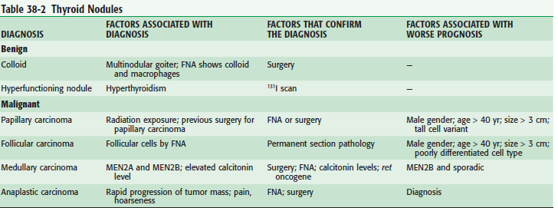

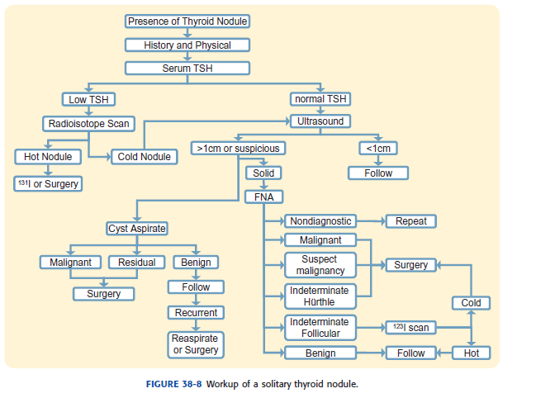



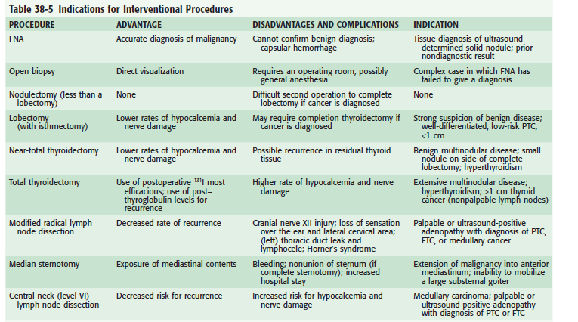

**26. BURNS**

Burns are tissue injuries resulting from direct contact with flames, hot liquids, gases, or surfaces; caustic chemicals; electricity; or radiation.

**ASSESMENT AND MANAGEMENT OF BURN INJURIES**

The mechanism of injury-inhalation burns suspected when there is history of being entrapped in smoke or gases, burns on palate or nasal mucosa or deep burns around mouth and neck.

Associated injuries-fractures, abdominal organ injuries, pulmonary contusion and pneumothorax etc

Pre hospital treatment

State of health- pre existing medical problems like cardiac, renal, pulmonary, GIT.

Airway assessment

Breathing

Circulation

Remove all clothing to assess the full extent of body surface involvement.

**ASSESMENT OF BURNS**

**Percentage of burns—rule of nine**

Upper limb-9% each

Lower limb- 18% each (14% in case of infants)

Trunk 36% as 18% anterior and 18% posterior

Head and neck-9% (18% in case of infants)

Perineal region-1%

OXYGENATION- 100% oxygen high humidity facemask with possible inhalation injury

IV Access-all patients with >20% BSA(>10% in children) require IVF through peripheral venous access.

**FLUID REQUIREMENT IN BURN PATIENT**

Calculated according toParkland formula= 4 x TBSA x Weight of person

Half of this fluid is to be given in first 8 hrs and rest in next 16 hrs

Ringer lactate is the preferred IVF

**Foley’s catheter** to monitor urine output

Maintain Urine output >1 ml /kg/hr.

**Escharotomy**-may be necessary in cases of full thickness circumfrential burns of neck, torso, or extremities

**Continuous pulse oximetry** to measure oxygen saturation

**OPTHALAMIC CONSULTATION** in case of eye injury

**ENT CONSULTATION** in case of laryngeal edema and inhalational burns

**CLASSIFICATION OF BURNS BASED ON THICKNESS**

1.**Superficial partial thickness burns**-not deeper than papillary dermis,pink and moist, blisters ,capillary return present on blanching.

2.**Deep partial thickness burns**-due to damage to deeper part of reticular dermis, no blanching,sensations reduced not as moist as superficial burns.

3.**Full thickness burns-** whole thickness of dermis is destroyed, hard leathery feeling, no capillary return, complete anaesthesia.

Adequate analgesia -NSAIDS, Opoids.

Antibiotics-Initially broad spectrum antibiotics are used and later on according to culture sensitivity.

Steroids

High protein diet

Vitamin supplementation

Daily ASD - silver sulphadiazine(effective against pseudomonas)

Physiotherapy

Delayed reconstruction

**ELECTRICAL BURNS**

1. **Low voltage injuries-** does not causes sufficient damage to subcutaneous tissues. Small entry and exit burns in fingers, tetany may be present. AC can cause cardiac arrest by interfering with normal cardiac rhythm.

2. **High voltage injuries –**flash burns causes damage to tissues and muscles .Entry and exit wounds causes excessive tissue damage. Compartment syndrome,myoglobinurias and renal dysfunction may be there.Fasciotomy may be required in case of compartment syndrome.

**CHEMICAL BURNS** –

Acidic or alkali burns

Damage is from corrison and poisoning.

Copious lavage with water helps in most cases.

Identify the chemical and assess the risk of absorption.

**27. SOFT TISSUE INFECTION**

**Impetigo**

History and physical examination

CBC, FBS, RBS, RFT

Treatment

Topical antibiotic

Oral antibiotic

**Erysipelas**

History and physical examination

CBC, FBS, RBS, RFT, Electrolytes

Culture and senstivity

Treatment

Oral antibiotic

**Cellulitis/Lyphangitis**

History and physical examination

CBC, FBS, RBS, RFT, Electrolytes, C Reactive protein, USG

Culture and sensitivity, Blood culture

Treatment

Elevation of affected limb

Oral/Intravenous antibiotic

Magnesium sulphate ointment

**Necrotizing Fasciitis**

History and physical examination

CBC, FBS, RBS, RFT, Electrolytes, C Reactive protein

Culture and sensitivity, Blood culture

Treatment

Fluid resuscitation

Broad spectrum high dose Intravenous antibiotic

Debridement

Vacuum assisted dressings

Grafting

**Abscess**

History and physical examination

CBC, FBS, RBS, RFT, Electrolytes

Culture and senstivity

Treatment

Incision and drainage

Oral/ intravenous antibiotic

Aspiration

Dressing

**Carbuncle**

History and physical examination

CBC, FBS, RBS, RFT, Electrolytes, Urine analysis

Culture and senstivity

Treatment

Incision and drainage

Oral/ intravenous antibiotic

Control of diabetes

Dressings

**Furuncle**

History and physical examination

CBC, FBS, RBS

Treatment

Oral/ topical antibiotic

Incision and drainage

Control of diabetes if present

**28. DIABETIC FOOT**

Foot complications are common in diabetes.

Microvascular and macrovascular disease refers to damage that occurs to blood vessels within the body. Another complication is peripheral vascular disease (PVD) which is damage caused to blood vessels supplying lower limbs. This can cause poor circulation, resulting in pain and predisposing patients’ feet to the development of ulceration, which can lead ultimately to amputation.

Another complication is neuropathy, which can lead to loss of sensation in the feet, approximately 20 – 40% of people diabetes develop neuropathy. Neuropathy and PVD are secondary to poor blood glucose control and adverse arterial risk factors (such as smoking or dyslipidaemia). Where neuropathy and ischaemia lead to ulceration (especially with poor glucose control), the foot can become infected, often with polymicrobial invasion and it may need to be amputated if the infection is not managed appropriately. Patients undergoing lower limb amputations exhibit a mortality rate of 50 – 75% within five years.

POTENTIAL CONTRIBUTORY FACTORS LEADING TO FOOT ULCERATION AND INFECTION:

• Friction in ill fitting or new shoes

• Neglect

• Untreated callus

• Self treated callus

• Foot injuries (for example, unnoticed trauma in shoes or when walking barefoot)

• Burns (for example, excessively hot bath, hot water bottle, hot radiators)

• Corn plaster

• Nail infections

• Artifactual (self inflicted foot lesions are rare: occasionally failure to heal is due to this cause)

• Heel friction in patients confined to bed

• Foot deformities ( callus, clawed toes, bunions, pes cavus, hallux rigidus, hammer toe, Charcot’s foot neuro-arthropathy, deformities from previous trauma or surgery, nail deformities, oedema)

FOOT CARE: general management approach

• Effective care involves a partnership between patients and professionals, and all decision making should be shared.

• On diagnosis, a full holistic assessment should be completed to determine the level of risk the foot poses.

• A management plan should be agreed with patients that includes appropriate foot care education, including risks and benefits of treatment/care plan and documented in the patient records.

• An appropriate individual care plan will be mutually agreed between the patient and the health care professional.

• Education will form part of the care plan.

• Check the patient has been recalled for annual foot screening depending on who is providing the care i.e. podiatry service, patients GP, or secondary care depending on their risk category and individual circumstances. If the patient has not been re called the nurse must follow this up and record outcome in the health records

• Extra vigilance should be used for people who are older, have had diabetes for a long time, have poor vision, have poor footwear, smoke, are socially deprived or live alone. Any clinical concerns regarding non concordance needs to be recorded in the patients health records.

• To promote optimal glucose levels to meet individual health needs and control of risk factors for cardiovascular disease.

ON DIAGNOSIS OF DIABETES AND ONGOING CARE

On diagnosis the patient’s lower limbs and feet are examined to include:

• Testing of foot sensation

• Palpation of foot pulses

• Inspection of foot deformity

• Inspection of footwear. The outcome of this process will include:

• Patients will be risk classified

• Patients will have an agreed care plan according to their risk classification

• Patients will receive appropriate education based on their risk classification

• Patients will be referred to the appropriate services based on the results of their screening.

Nursing staff should be aware of the following risk categories: High Risk Patients who have had a previous foot ulcer or amputation should routinely examine their feet on a daily basis for broken skin, blisters and inflammation, using the aid of a mirror if necessary – this should be incorporated into the patient’s care plan. Patients are advised to attend their local accident and emergency department when broken skin, blisters, swelling and inflammation are observed. Any delay in getting treatment and advice could lead to further complications.

All high risk patients should have a follow up appointment with the Trust Community Podiatry Service in their possession. At Risk Patients who have reduced sensation, absent pulses, neuropathic pain and possible foot deformity are at risk of diabetic foot ulcers. Patients should be referred to podiatry services where they will be assessed for their need relating to the following and reviewed annually:

• Vascular assessment

• Specialist footwear/insoles

• Treatment for painful neuropathy

• Glycaemic control

Low Risk Patients with palpable pulses and normal sensation are classed as low risk. Patients should routinely examine their feet for broken skin, blisters and inflammation on a daily basis. Advice and treatment should be sought immediately by patients from their GP or Practice Nurse when signs of infection i.e. pain, swelling, bleeding, discolouration or a sudden increase in temperature are evident. Annual diabetic foot screening is provided by their GP.

MONTHLY REVIEW

Patients that fit the following criteria will receive 1-3 monthly foot assessments:-

• Insulin dependent diabetic

• House bound

• Unable to self care Patients are examined to include:

• Observational foot inspection

• Inspection of footwear.

The outcome of this process is that:

• Patients will receive appropriate health education as required

• Patients will be referred to the appropriate services based on the results of their review as soon as possible and followed up. Checks should be made as to whether a patient is already reviewed by the Trust’s Podiatry Service

• When relevant, any clinical concerns must be shared with GP.

COMPLICATIONS

Neuropathy

Peripheral neuropathy is degeneration of the peripheral nerves which can lead to loss of sensation, motor and autonomic dysfunction. It may also lead to severe foot problems. Detection of neuropathy results in the classification of a patient being increased or high risk. Vascular Disease Peripheral vascular disease in the form of atherosclerosis of the leg vessels causes loss of circulation (ischaemia which is often bilateral, multisegmental and distal). Detection of peripheral vascular disease results in the classification of a patient being increased or high risk.

Ulceration

Aetiology / Risk Factors Long-term risk factors for foot ulcers and amputation include duration of diabetes, poor glycaemic control, microvascular complications (retinopathy, neuropathy, and nephropathy), peripheral vascular disease, foot deformities, and previous foot ulceration or amputation. Strong predictors of foot ulceration are altered foot sensation, foot deformities, and previous foot ulcers or minor or major amputation of part of the other foot or amputation of all of the foot.

Charcot Foot

Charcot osteoarthropathy is a progressive condition, characterised by peri-articular fractures and destruction of the bony structures. It is associated with sensory neuropathy. In the majority of patients with Charcot arthropathy, the midfoot or inner longitudinal arch collapses. The acute swelling and the later deformity associated with this are major risk factors for ulceration and subsequently amputation. Foot trauma in a neuropathic foot may be a trigger for the development of Charcot osteoarthropathy. Continued walking promotes progression of the osteoarthropathy and will worsen the deformity.

**29. CHRONIC VENOUS INSUFFICIENCY**

# Introduction

Chronic venous disease includes cosmetically undesirable telangiectasias, varicose veins, venous ulceration, and claudication.

## I. Pathophysiology

### A. Etiology

* Congenital (although it may present later in life), primary (cause undetermined), or secondary (postthrombotic, posttraumatic, or other).
* Risk factors
  + Obesity.
  + Tobacco use.
  + Multiparity.
  + Hormone therapy.
  + Obstruction within a proximal segment (e.g., from adenopathy, arterial compression, or pregnancy).
  + History of deep venous thrombosis (DVT). DVT accounts for most secondary cases and may be responsible for a significant number of other cases because many deep vein thrombi are asymptomatic.

### B. Reflux disease

Reflux disease from venous valvular incompetence accounts for most (>80%) chronic venous disease.

* Valve malfunction

### C. Obstructive physiology

Obstructive physiology is a less common cause of venous pathology, with reflux often being present simultaneously.

## II. Differential Diagnosis

* Arterial disease
  + Ulcers with discrete edges and pale bases; more painful than venous ulcers.
  + Poor pulses.
  + Dependent rubor.
  + Pallor with elevation.
  + Claudication.
* Lymphedema
  + Pitting edema without pigmentation and ulceration.
  + Less responsive to elevation, usually requiring several days to improve.
* Squamous cell carcinoma
* Trauma
* Arteriovenous malformation
* Orthostatic edema

## III. Nomenclature

### CEAP classification

|  |
| --- |
| **Classification of Chronic Lower-Extremity Venous Disease** |
| |  |  | | --- | --- | | **Classification** | **Definition** | | C | Clinical signs (grade 0–6),a supplemented by (A) for asymptomatic or (S) for symptomatic presentation | | E | Etiologic classification (congenital, primary, or secondary) | | A | Anatomic distribution (superficial, deep, or perforator; alone or in combination) | | P | Pathophysiologic dysfunction (reflux or obstruction; alone or in combination) | |  | | |

### B. Venous Clinical Severity Score (VCSS)

* Ten clinical descriptors: pain, varicose veins, venous edema, skin pigmentation, inflammation, induration, number of active ulcers, duration of active ulceration, size of ulcer, and compressive therapy use.
* Better assesses ongoing response to therapy.

## IV. Diagnosis

### A. History

* A history of any DVT or trauma.
* Family history of varicose veins or CVI.  
  Complaint of lower-extremity edema, aching, skin irritation, or varicose veins. Leg pain is described as a dull ache, worsening at the end of the day, and often relieved with exercise or elevation.
* Individuals can experience acute, bursting pain with ambulation (venous claudication). Prolonged rest and leg elevation (20 minutes) are needed to obtain relief.

### B. Physical examination

* Ankle edema.
* Subcutaneous fibrosis.
* Hyperpigmentation (brownish discoloration secondary to hemosiderin deposition).
* Lipodermatosclerosis.
* Venous eczema.
* Dilation of subcutaneous veins, including telangiectasias (0.1 to 1 mm), reticular veins (1 to 4 mm), and varicose veins (>4 mm).
* Ultimately, ulcers develop, typically proximal to the medial malleolus.
* Any signs of infection should be noted.
* Arterial pulses should be examined and are usually adequate.

### C. Noninvasive studies

* Duplex scanning

|  |
| --- |
| **Clinical Classification of Chronic Lower-Extremity Venous Disease** |
| |  |  | | --- | --- | | **Grade** | **Characteristics** | | 0 | No visible or palpable signs of venous disease | | 1 | Telangectasias, reticular veins, or malleolar flare | | 2 | Varicose veins | | 3 | Edema without skin changes | | 4 | Skin changes ascribed to venous disease (e.g., pigmentation, venous eczema, or lipodermatosclerosis) | | 5 | Skin changes as defined above and healed ulceration | | 6 | Skin changes as defined above and active ulceration | |  | | |

* Descending phlebography.
* Continuous-wave Doppler
* Trendelenburg test
  + Largely replaced by the much more accurate duplex imaging studies.
  + Patient's leg is elevated to drain venous blood. An elastic tourniquet is applied at the saphenofemoral junction, and the patient then stands.
  + Rapid filling (<30 seconds) of the saphenous system from the deep system indicates perforator valve incompetence.
  + When tourniquet is released, additional filling of the saphenous system occurs if the saphenofemoral valve is also incompetent.

## V. Nonsurgical Treatment

### A. Infected ulcers

* Necessitate treatment of the infection first.
* Staphylococcus aureus, Streptococcus pyogenes, and Pseudomonas species are responsible for most infections.
* Usually treated with local wound care, wet-to-dry dressings, and oral antibiotics.

### B. Leg elevation

Leg elevation can temporarily decrease edema and should be instituted when swelling occurs. This should be done before a patient is fitted for stockings or boots.

### C. Compression therapy

Compression therapy is the primary treatment for CVI.

* *Elastic compression stockings*
  + Fitted to provide a compression gradient from 30 to 40 mm Hg, with the greatest compression at the ankle.
* *Unna boots*
  + Paste gauze compression dressings that contain zinc oxide, calamine, and glycerin.
  + Used to help prevent further skin breakdown.
* *Pneumatic compression devices*
  + Provide dynamic sequential compression.
  + Used primarily in the prevention of deep vein thrombi in hospitalized patients.

### D. Topical medications

* Largely ineffective as a stand-alone therapy for venous stasis ulcers.
* Topical therapy is directed at absorbing wound drainage and avoiding desiccation of the wound.
* Antiseptics can be counterproductive. Hydrogen peroxide, povidone-iodine, acetic acid, and sodium hypochlorite are toxic to cultured fibroblasts and should be used for the shortest duration necessary to control ulcer infection.

### E. Sclerotherapy

* Effective in treating telangiectasias, reticular varicosities, and small varicose veins.
* If saphenous reflux is present, it should be corrected first.
* Sclerosing agents
  + 1% or 3% sodium tetradecyl sulfate.
  + Sodium morrhuate (rarely used because of anaphylactic reactions).
  + Hypertonic saline.
  + Polidocanol (not currently Food and Drug Administration approved in the United States).

## VI. Surgical Therapy

Surgical Therapy is indicated for severe disease refractory to medical treatment and for patients who cannot comply with the lifelong regimen of compression therapy. Surgical therapy includes *Stripping the greater saphenous vein*

* *Endovenous radiofrequency or laser obliteration of the greater saphenous vein*
* *The stab avulsion technique allows a cosmetically acceptable surgical approach to varicose veins*.
* *Additional procedures*
  + For severe CVI, more extensive surgery is required, usually directed at correction of saphenous reflux and ligation of incompetent medial calf perforators..

Open surgical subfascial ligation (the Linton procedure)

* + Subfascial endoscopic perforating vein surgery

## VENOUS THROMBOEMBOLISM

## I. Epidemiology

* Venous thromboembolism, which includes DVT and pulmonary embolism (PE), has an annual incidence of one to two events per 1,000 of the general population.
* An equal incidence between men and women has been observed.
* From 50% to 60% of DVT episodes are asymptomatic. Of those patients with DVTs, 30% will have a symptomatic PE with a mortality of 17.5% if untreated.

## II. Pathophysiology

* DVT starts as a platelet nidus, activating the clotting cascade, leading to platelet and fibrin accumulation.
* The fibrinolytic system is subsequently activated, with thrombus growth if thrombogenesis predominates over thrombolysis.
* Approximately 20% of cases of calf DVT propagate to the thigh, and 50% of cases of thigh or proximal DVT embolize.

III. Risk Factors for Venous Thromboembolism

* 1. Malignancy
  2. Endothelial injury
  3. Venous stasis
  4. Oral contraceptives (OCPs) and estrogen hormone replacement therapy
  5. Hypercoagulable states

## IV. Diagnosis

### A. Initial evaluation

* Clinical presentation
  + Extremity pain.
  + Increased circumference with respect to contralateral extremity.
  + Dilation of superficial veins of the suspected extremity only.
  + Calf pain on dorsiflexion of the ankle.
  + Phlegmasia alba dolens
  + Phlegmasia cerulea dolens

**B. Suspected DVT**

* Compression ultrasonography represents the preferred diagnostic modality because it is less invasive than the reference standard of venography and is more sensitive than impedance plethysmography.
* Approximately 2% of patients with initial normal ultrasound results have positive results on repeat tests performed 7 days later.

### C. Assessment of PE

* Contrast-enhanced spiral computed tomography (CT), preferable to angiography (less invasive and less expensive).
* Chest CT can be combined with CT angiography of pelvic and deep thigh veins to detect DVT as well as PE.
* Radionucleotide ventilation and perfusion lung imaging (V/Q scan) V/Q scanning is used in situations in which CT is deemed not feasible.
* Pulmonary angiography, the reference test, is reserved for patients whose diagnosis is still uncertain.

## V. Prevention and Treatment of Venous Thromboembolism

* *Low-dose unfractionated heparin*
  + This is given subcutaneously at 5,000 units 2 hours before surgery and every 8 or 12 hours postoperatively.
* *Graduated compression stockings*
  + These are effective in preventing DVT formation by reducing venous stasis.
* *Intermittent pneumatic compression of the extremities*
* *Low–molecular-weight heparins (LMWHs)*
* *Newer medications* such as the direct thrombin inhibitors (DTIs) and fondaparinux represent a possible alternative to the unfractionated and LMWHs in the prevention of thromboembolic disease.
* *Caval interruption with intracaval filters*

**30. PERIPHERAL ARTERIAL DISEASE**

PAD is the preferred clinical term and should be used to denote stenotic, occlusive and aneurysmal diseases of the aorta and its branch arteries, exclusive of the coronary arteries.

# Risk Factors for Lower Extremity Peripheral Arterial Disease

* Age less than 50 years, with diabetes and one other atherosclerosis risk factor(smoking, dyslipidemia, hypertension, or hyperhomocysteinemia)
* Age 50 to 69 and a history of smoking and diabetes
* Age 70 or older
* Leg symptoms with exertion (suggestive of claudication) or ischaemic rest pain
* Abnormal lower extremity pulse examination
* Known atherosclerotic coronary, carotid, or renal artery disease

## SYMPTOMATOLOGY

• Any *exertional* limitation of the lower extremity muscles or any history of walking impairment (described as fatigue, aching, numbness, or pain, occurring in the buttock, thigh, calf, or foot).

• Any poorly healing or non healing wounds of the legs or feet.

• Any pain at rest localized to the lower leg or foot, and its association with the upright or recumbent positions.

• Postprandial abdominal pain provoked by eating, and is associated with weight loss.

• Family history of a first degree relative with an abdominal aortic aneurysm (AAA).

## Vascular Physical Examination

• Measurement of blood pressure in both arms

• Palpation of the carotid pulses

• Auscultation of the abdomen and flank for bruits.

• Palpation of peripheral pulses

• Ausculation of both femoral arteries for the presence of bruits

• Pulse intensity should be assessed and should be recorded numerically as follows:

− 0, absent

− 1, diminished

− 2, normal

− 3, bounding

• The shoes and socks should be removed, the feet inspected, the color, temperature, and integrity of the skin and intertriginous areas evaluated, and presence of ulcerations recorded.

• Additional findings suggestive of severe PAD, including distal hair loss, trophic skin changes, and hypertrophic nails, should be sought and recorded.

**Diagnosis and Treatment of Asymptomatic PAD and Atypical Leg Pain**

Lower Extremity Arterial Disease

## A. Claudication

Claudication is defined as fatigue, discomfort, or pain that occurs in specific limb muscle groups during effort due to exercise-induced ischemia .

Diagnosis of Claudication and Systemic Risk Treatment

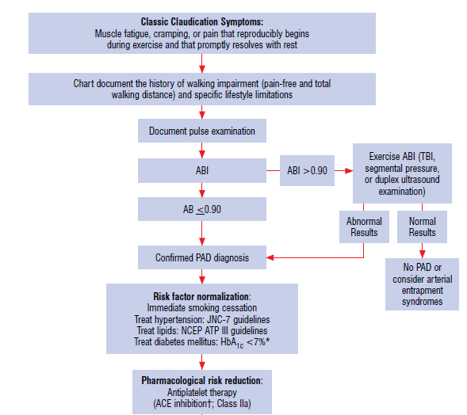

# Treatment of Claudication

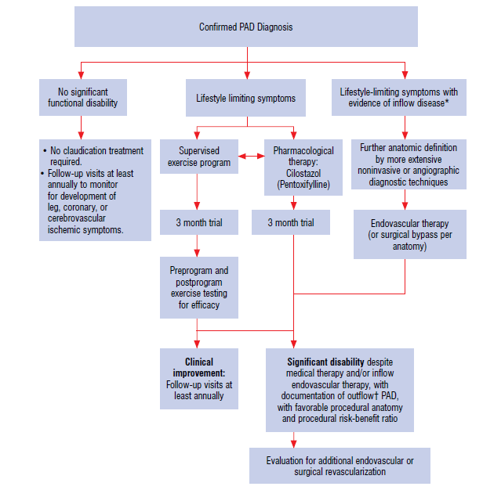

# Treatment of Claudication

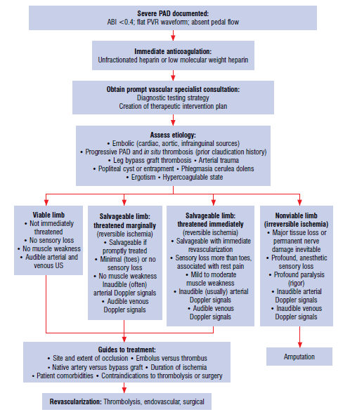

## Endovascular Treatment of Claudication

Angioplasty

Baloon expendable stents

Self expanding stents

Bioadsorbabale stents

Cryoplasty

Cutting baloon

Mechanical athrectomy

Laser

# Critical Limb Ischemia

CLI is defined as limb pain occurring at rest or impending limb loss that is caused by severe compromise of blood flow to the affected extremity.

Acute Limb Ischemia

Acute limb ischemia is defined as a rapid or sudden decrease inlimb perfusion that threatens limb viability.

Diagnosis of Acute Limb Ischemia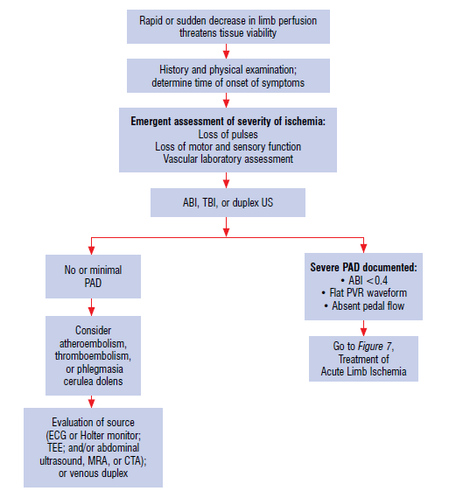

## Management of Patients with Acute Limb Ischemia

Catheter based thrombolysis( acute episode of less than 14 days)

Mechanical thrombectomy

Smoking cessation-Patients should be assisted with counseling and developing a plan for quitting that may include pharmacotherapy and/or referral to a smoking

cessation program

For all patients in the absence of contraindication, nicotine replacement therapy should be considered.

Lower Extr

## Antithrombotic and Antiplatelet Therapy

Aspirin, typically in daily doses of 75 to 325 mg

Clopidogrel (75 mg per day) is recommended as asafe and effective alternative antiplatelet therapy

Lower Extremity